

user manual

by team jiminy cricket

|  |  |  |
| --- | --- | --- |
|  | Charles Madere |  |
| Geonathan Sena |  | Jarrad Pinestraw |
|  | Joseph Gautier |  |

We Paint requires two simple prerequisites! Please read this page to find out if you can use We Paint.

1. We Paint requires that you have a Facebook account in order to draw. Making a Facebook account is easy, just go to facebook.com.



2. We Paint requires that you have a modern web browser such as Google Chrome, Internet Explorer 9, or Mozilla Firefox.

Did you pass the prerequisites? Great! Continue to the next page to learn about out how to participate in We Paint.

1. To begin using We Paint, simply open up your web browser and go to wepaint.us. It will look like this:

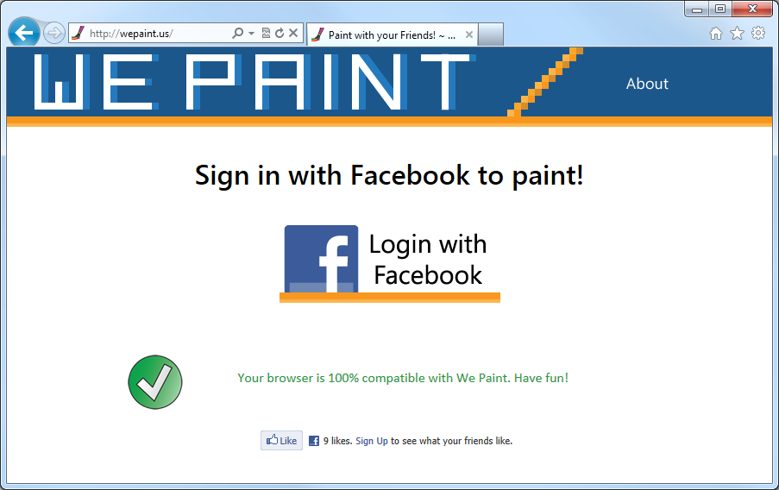

2. Click on the image that says Login with Facebook, which will bring you to this page:

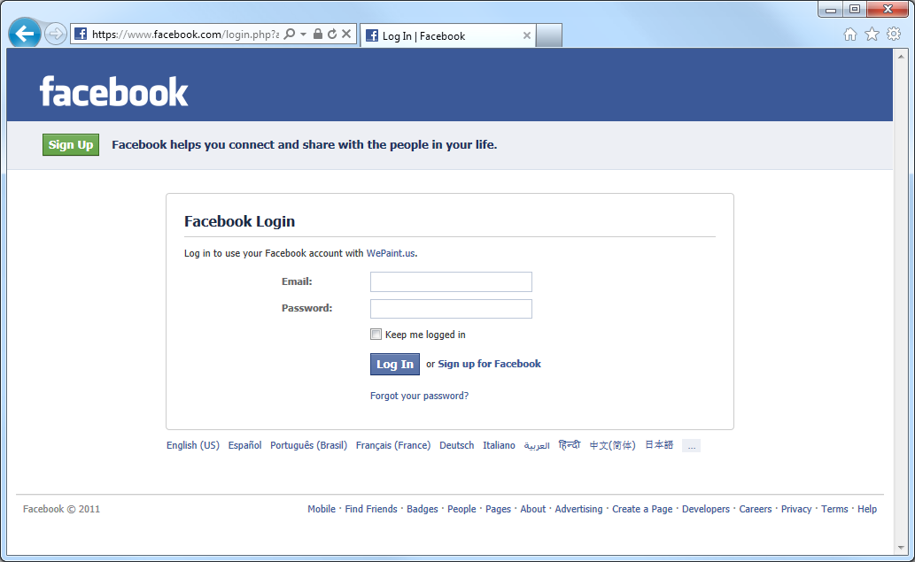

Just enter in your Facebook details as you would normally use to login to your account.

3. At this point We Paint will ask you to grant it permissions to access your Facebook account. Just press *Log In*.

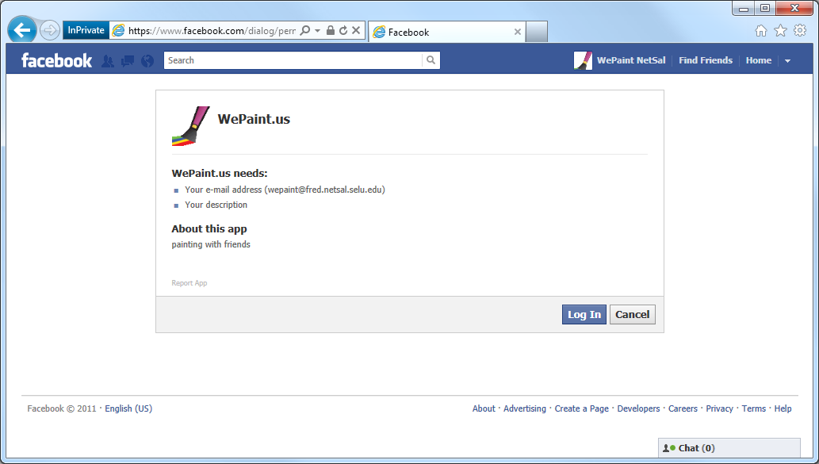

4. Again, We Paint will ask for permissions. Just press *Allow*.

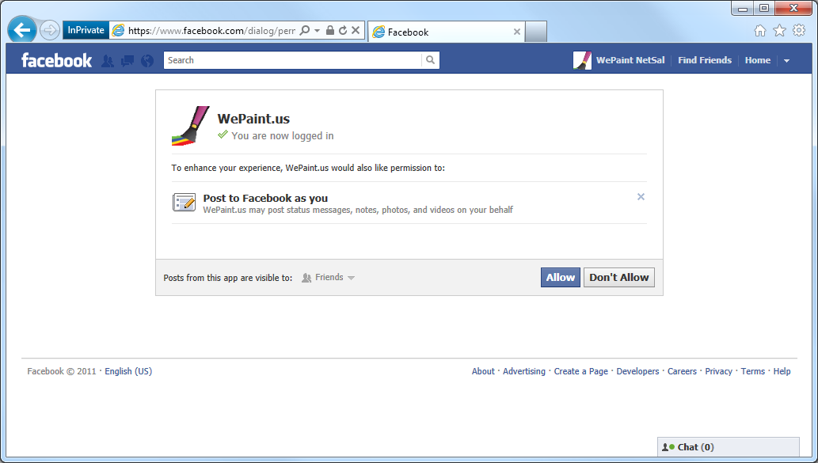

After pressing *Allow*, you will be returned to the We Paint page.

5. You are almost ready to draw! But first, would you like your friends to view your work in real time? To invite all of your Facebook friends to view, just click the *Invite your Friends!* image. You can then allow We Paint to make a post on your Facebook news feed, asking all of your friends to join you.

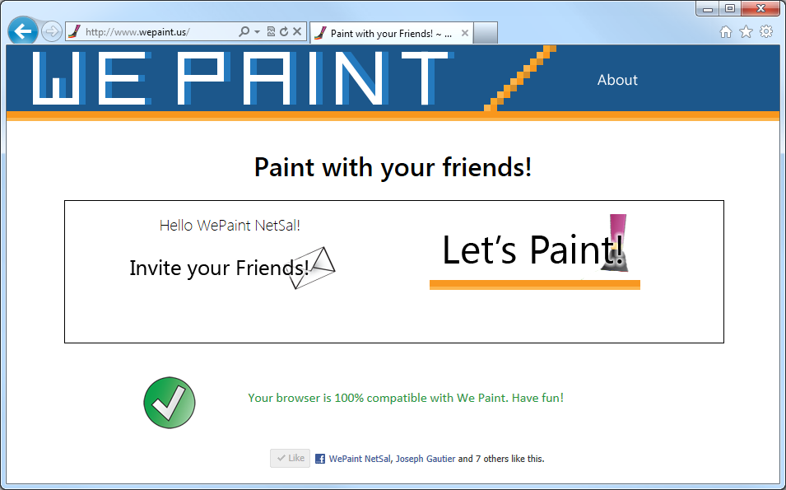

If you’d rather draw alone, or just invite your friends later, click the *Let’s Paint!* button to get to the drawing board.

6. Text

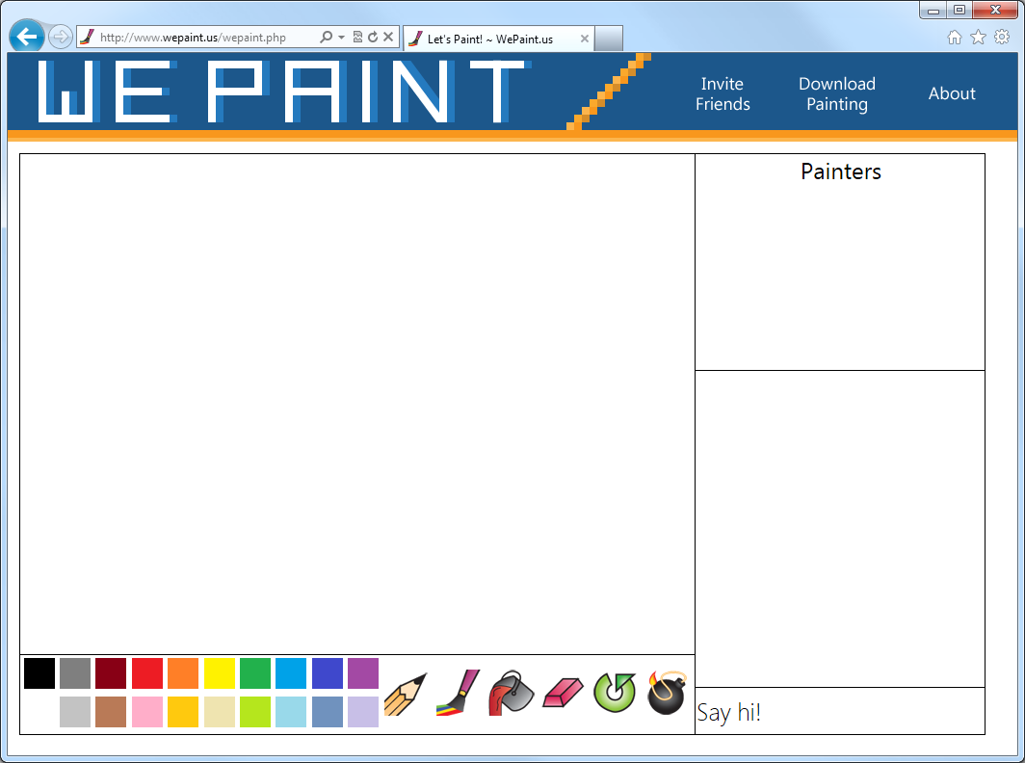

thanks for trying We Paint!

